**THE HATCH QUEST**

**by**

**Akın Kekikciler**

**Graduation Project Report**

**Yeditepe University**

**Faculty of Computer and Information Sciences**

**Department of Software Development**

**2024**

**THE HATCH QUEST**

APPROVED BY:

Assist.Prof.Dr. Name Surname ………………………………  
(Supervisor)

Assoc.Prof.Dr. Name Surname ………………………………

Prof.Dr. Name Surname ………………………………

DATE OF APPROVAL: / /2024

**ACKNOWLEDGEMENTS**

I would like to thank my advisor Assist. Prof. Dr. Bekir Tevfik Akgün for his guidance and support throughout my project.

ABSTRACT

THE HATCH QUEST

My project aims to introduce a unique mechanic into a clicker game by integrating external purchases through a PHP, HTML, and MySQL website. The game, developed using the Unity engine, revolves around the player breaking dragon eggs by clicking on them, with each egg having increasing health. To hatch difficult eggs, players are required to purchase upgrades and enhancements using a separate website.

Core gameplay loop involves players clicking on dragon eggs to lower their health and earn gold with each click. I’ve added a layer of challenge with eggs regenerating health over time. If players are stuck on a specific level and in order to progress through to the next one, players must exit the game and navigate to the designated website to purchase necessary upgrades.

The website is developed using PHP for server side, HTML/CSS for frontend design, and MySQL for database management. These upgrades include increased click damage, auto clickers, gold multipliers, critical strike chances etc.

ÖZET

THE HATCH QUEST

Projem, oyun içi satın alımları PHP, HTML ve MySQL kullanarak web sitesi aracılığıyla entegre ederek tıklama oyununa benzersiz bir mekanik katmayı amaçlıyor. Unity motoru kullanılarak geliştirdiğim oyun, oyuncunun ejderha yumurtalarına tıklayarak kırması şeklinde ilerliyor ve her bölümde karşılaşılan yumurtalar bir öncekine göre daha zorlu oluyor. Zorlu yumurtaları kırmak için oyuncuların ayrı bir web sitesi kullanarak yükseltmeleri ve geliştirmeleri satın almaları gerekir.

Oyun, ejderha yumurtalarının sağlıklarını azaltmak için tıklanmasıyla oynanıyor. Zorluk katmanı olarak yumurtalara zamanla sağlık yenilenmesi mekaniği ekledim. Eğer oyuncular belirli bir seviyede takılıp geçemezlerse, bir sonraki seviyeye ilerlemek için oyuncuların oyun arayüzünden çıkmaları ve gerekli yükseltme satın alımlarını yapmak üzere belirlenen web sitesine gitmeleri gerekir.

Web sitesi, server side için PHP, front end tasarım için HTML/CSS ve veritabanı yönetimi için MySQL kullanılarak geliştirildi ve oyuncuların yükseltmelere göz atabileceği ve satın alabileceği bir platform olması amaçlandı. Satın alınabilecek yükseltmeler arasında artırılmış tıklama hasarı, otomatik tıklamalar, altın çarpanları ve ilerlemeyi kolaylaştırmayı amaçlayan diğer geliştirmeler yer alıyor.

Projem harici satın almalar uygulayarak oyunculara benzersiz bir mekanik sağlamayı amaçlıyor. Bu benzersiz mekanizma, oyuncuları hem Unity arayüzünde hem de harici bir web sitesi platformu aracılığıyla oyunu oynamaya teşvik ediyor.

**TABLE OF CONTENTS**

1. INTRODUCTION 1

2. GAME DESIGN 3

2.1. Concept and Theme 3

2.2. Game Mechanics 3

2.3. Level Design 3

3. DEVELOPMENT PROCESS 6

3.1. Tools and Technologies 6

4. DESIGN AND IMPLEMENTATION 14

4.1. Architecture 14

4.2. Code Snippets 14

6. REFERENCES 20

# INTRODUCTION

**History of Video Games**

Video games are now a big part of modern entertainment, enjoyed by millions of people around the world. They have come a long way, starting with basic, blocky graphics and growing into realistic virtual reality experiences.

From the earliest days of computers, gaming emerged as a practical way to showcase the capabilities of these new machines. In the 1940s and 1950s, when computers were massive and expensive, games like tic-tac-toe and Tennis for Two served to attract public interest and challenge programmers to push the limits of early computing resources.

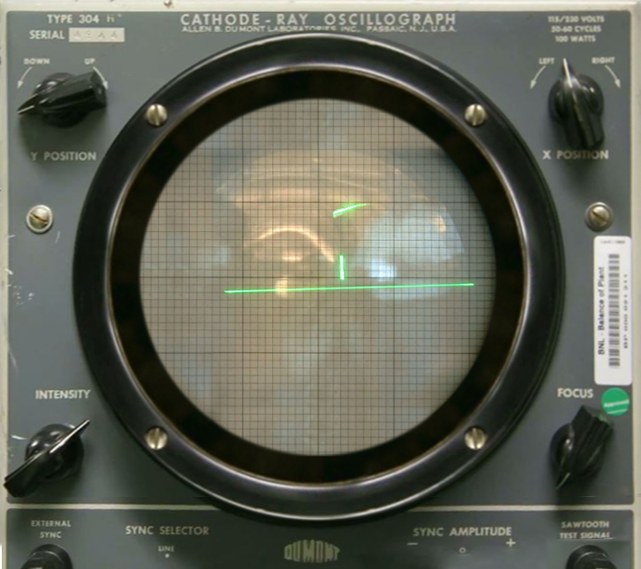

One pivotal moment came in the 1960s at MIT, where Steve Russell and his peers created "Spacewar," an interactive game between two spaceships inspired by science fiction. Although restricted to research facilities due to computer costs, "Spacewar" sparked interest in interactive entertainment among early computer enthusiasts.

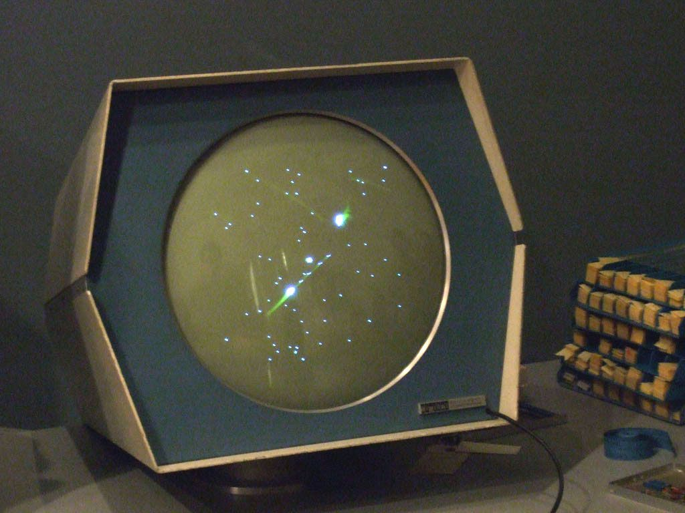

Simultaneously, engineer Ralph Baer at Sanders Associates saw potential in using television technology for games. His team developed the first video game test units in the late 1960s, leading to the creation of the "Brown Box," licensed to Magnavox as the Odyssey in 1972. Despite initial setbacks and misconceptions about its compatibility, the Odyssey marked a significant step towards commercializing video gaming.

Nolan Bushnell, influenced by his experiences with "Spacewar" and arcade games, founded Atari in 1972. Their breakthrough came with "Pong," an arcade hit that also succeeded as a home console, sparking a wave of consumer interest and legal battles over patents with Magnavox.

The early 1970s saw the rise of home video gaming, with Pong leading the way. Coleco's Telstar, featuring Ralph Baer's recommended AY-3-8500 chip, became a mass-market success after overcoming regulatory hurdles in 1976.

By the late 1970s and early 1980s, second-generation consoles like the Atari 2600 and Intellivision expanded gaming options with interchangeable cartridges. However, the market became oversaturated with low-quality games, coupled with competition from emerging home computers like the Apple II and Commodore 64.

This glut led to a crash in the early 1980s, with plummeting sales and many companies exiting the video game market. Atari, once dominant, struggled to survive amidst the downturn. Yet, Nintendo's NES revitalized the industry in 1985, proving the enduring appeal of video games in mainstream culture, as Ralph Baer had envisioned years earlier.

**Casual Games**

A casual game is a video game targeted at a mass market audience, as opposed to a hardcore game, which is targeted at hobbyist gamers. Casual games may exhibit any type of gameplay and genre. They generally involve simpler rules, shorter sessions, and require less learned skill.They do not expect familiarity with a standard set of mechanics, controls, and tropes.

Countless casual games have been developed and published, alongside hardcore games, across the history of video games. A concerted effort to capitalize on casual games grew in the 1990s and 2000s, as many developers and publishers branded themselves as casual game companies, publishing games especially for PCs, web browsers, and smartphones.

# GAME DESIGN

## Concept and Theme

This project is a mix of fantasy and fun gameplay. Game is basically a clicker game where the main goal is to hatch dragon eggs by clicking on them. Each dragon egg gets harder to hatch as the level progresses so players need to purchase upgrades in order to beat tougher levels.

To make the game more challenging dragon eggs regenerate health over time so it’d be difficult for a player to hatch them. If the player wants to progress faster then they need to purchase upgrades through an external website. This website acts as a marketplace where players can buy upgrades like increased damage, automated clickers, and gold multipliers etc.

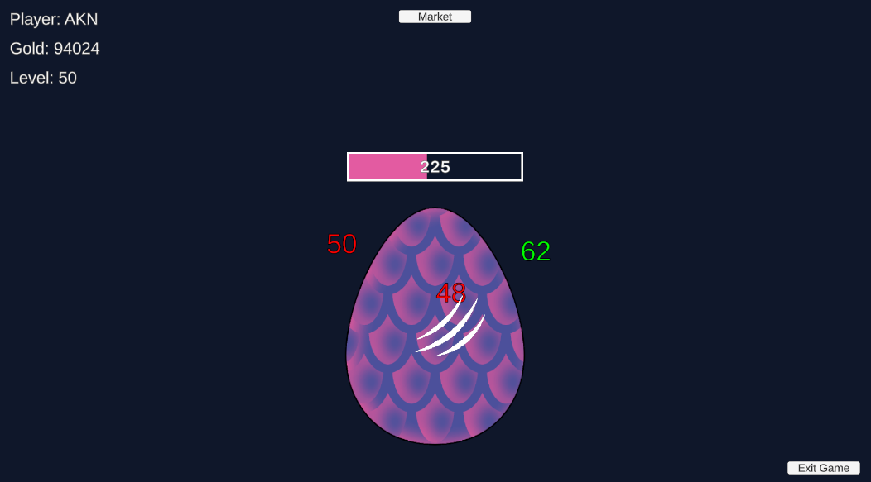

## Game Mechanics

**Clicking Mechanic:** Players click on dragon eggs to lower their health. Each click deals a certain amount of damage that can be increased by purchasing upgrades.

**Gold Earning:** Players will earn a certain amount of gold with each click. The amount of gold earned can also be increased through a specific upgrade.

**Egg Health and Regeneration:** Dragon eggs have different health levels that increase as players progress through the levels. To add a challenge, eggs also regenerate health over time, making it difficult to break them without enough upgrades.

**External Purchases:** To help progress through tougher levels, players can purchase upgrades using a website. These upgrades include:

**Increased Click Damage:** Boosts the damage dealt with each click, allowing players to hatch eggs faster.

**Auto Clickers:** Provides automated clicks every second, allows players to deal damage without clicking.

**Gold Multipliers:** Increases the amount of gold earned per click, allows players to purchase upgrades faster.

**Website Functionality:** Website acts as a marketplace for purchasing upgrades. Players must leave the game window to purchase them.

**Level Advancement:** Players progress through levels by successfully hatching eggs. Each level comes with eggs that have higher health and faster regeneration rates.

**Simple Controls:** The game uses easy mouse controls for clicking on eggs, making it accessible to players of all skill levels.

## Level Design

**Egg Variations:** Different levels feature eggs with different sizes and colors.

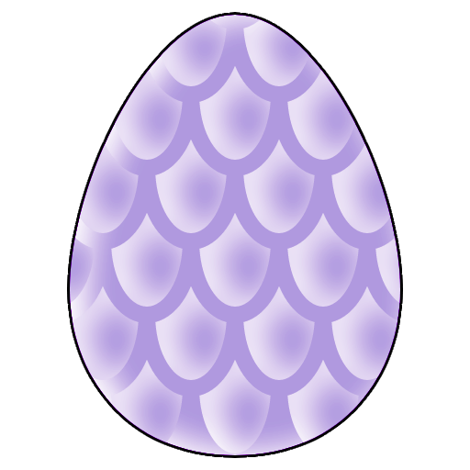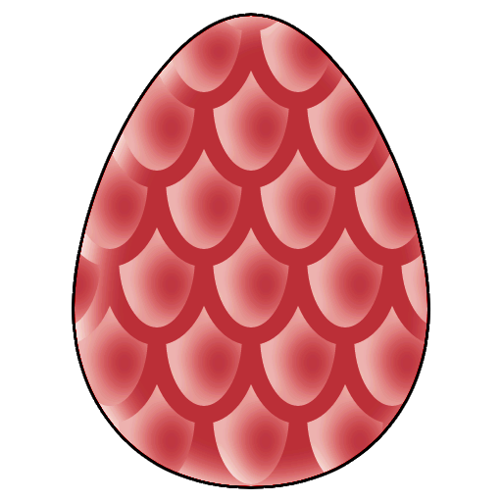

# DEVELOPMENT PROCESS

## Tools and Technologies

**Unity:** Game was developed using Unity, a game engine that supports 2D and 3D graphics. I chose Unity because I’m not familiar with other game engines.

**Server-Side:** I’ve used PHP for server-side scripting to handle requests from the game and manage interactions with the database.

**Integration with MySQL:** I’ve used PHP scripts to communicate with the MySQL database, retrieving and storing data related to users and upgrades.

**Frontend Design:** I’ve used HTML and CSS to design the frontend of the website where players can purchase upgrades.

**Database System:** I chose MySQL as the database management system because I’m not familiar with others. I used it to store and manage data related to users, their progress, and purchased upgrades.

**Graphic Design:** I’ve used Photopea to edit the visual assets of the game including dragon eggs and UI elements.

# DESIGN AND IMPLEMENTATION

## Architecture

Core mechanics such as handling player interactions, calculating damage, managing cold etc. are implemented in C#.

Communication between Unity to PHP done using Unity Web Requests. These requests handle transactions for purchasing upgrades, updating player data and retrieving game processes etc.

Backend logic is implemented in PHP that handles incoming requests from Unity. These requests interact with the MySQL database to retrieve and store data.

MySQL is used to manage data storage including users, purchased upgrades etc.

Website’s frontend is designed using HTML and CSS to provide a friendly interface for players to see and purchase upgrades.

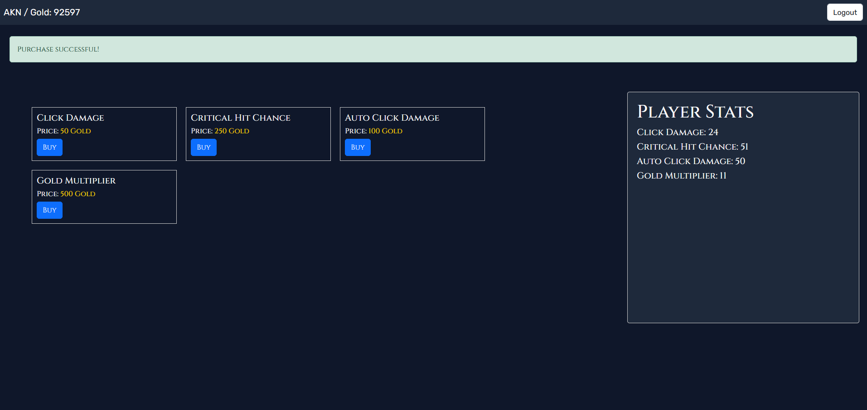

## Code Snippets

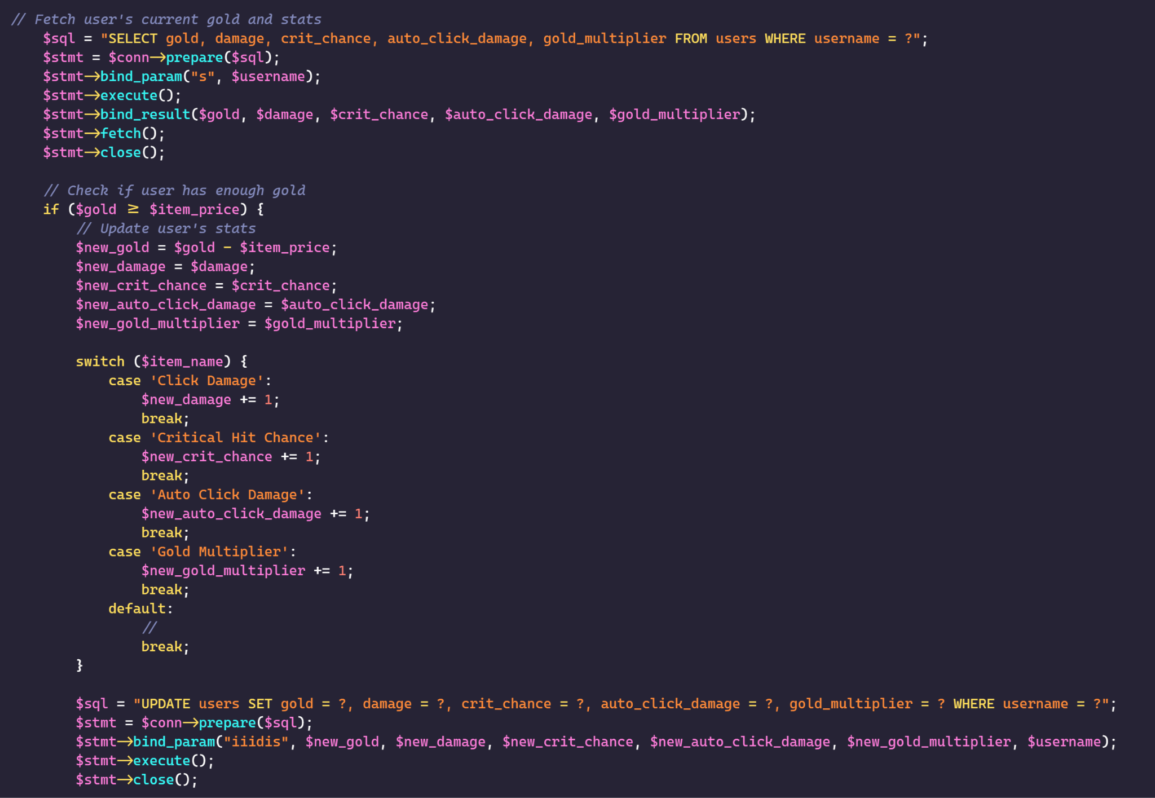

**buy_item.php**

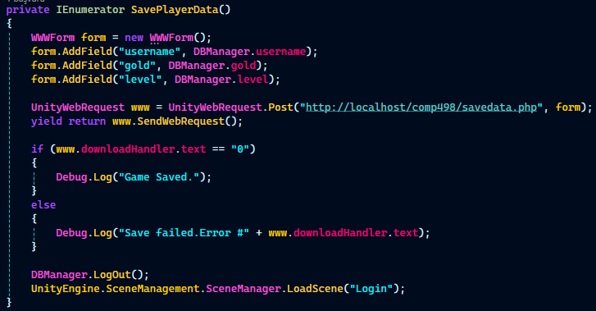**Game.cs > SavePlayerData** is for saving data to the user database and called when we log out of the game.

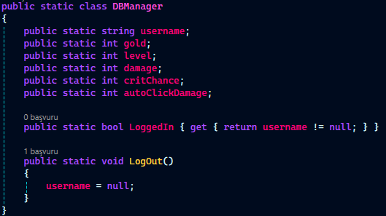

**DBManager.cs** is populated after we log in to the game with player’s stats from the database.

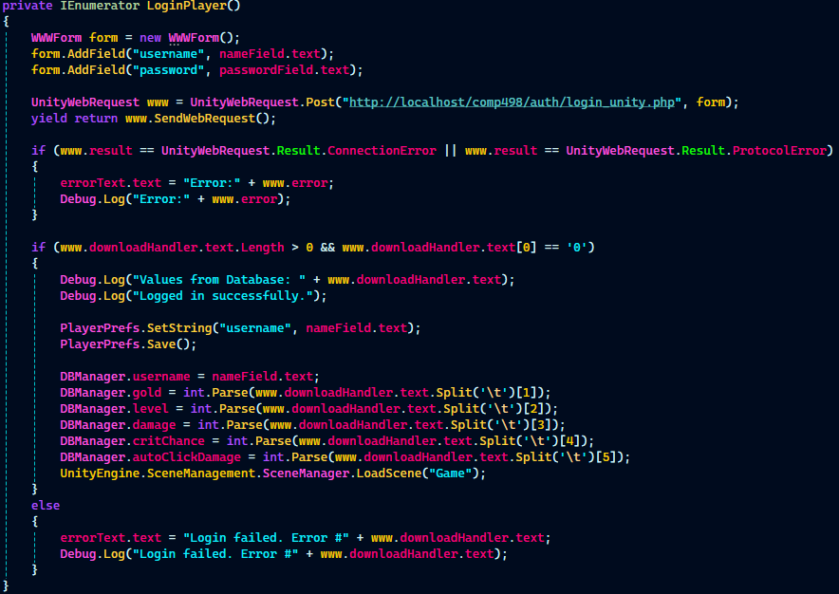

**Login.cs > LoginPlayer** is used to populate the DBManager.cs values.

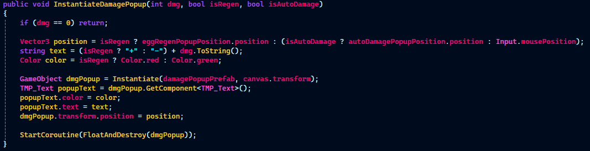

**DamagePopupManager.cs > InstantiateDamagePopup** is called when the player clicks on an egg or when an auto click happens to show how much damage they’ve inflicted as a floating pop up.

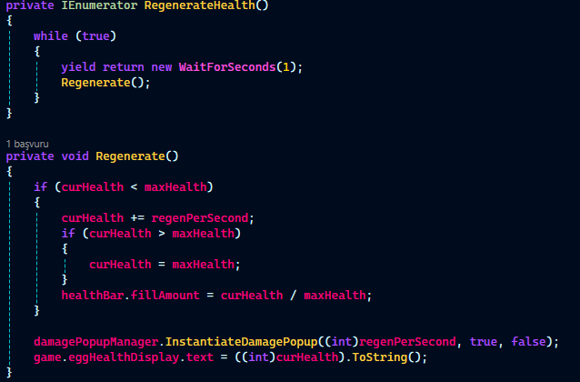

**Egg.cs > RegenerateHealth** is called every second to regenerate the egg’s health.

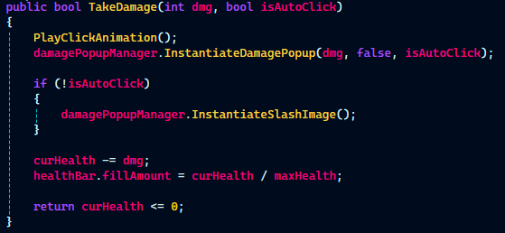

**Egg.cs > TakeDamage** is called when the egg takes damage.

# RESULTS

# References

<https://www.si.edu/spotlight/the-father-of-the-video-game-the-ralph-baer-prototypes-and-electronic-games/video-game-history>

<https://en.wikipedia.org/wiki/Casual_game>

<https://game-icons.net/>

<https://www.youtube.com/@BoardToBitsGames>

<https://www.photopea.com/>